9/1/2021 Deployment Notes
Contents

BHPH 2
384623 - Add Pre-Repo to Online payment restrictions 2
CRM 2
290049 - Appointment Confirmation mechanism 2
DEAL 7
363293 - Deal/Lender Partner - New Reserve Settings 7
395397 - Review the list of Required fields for running Credit Report button click on Deal Entry/Desking form. 9
393813- Nicholas Financial Enable Auto submit Nationwide 10
350418 – Nicholas Financial – Expansion to Arizona (Deployed 7/20/2021) 10
402904-Add other fee description to CA 10
405262 - OneMain State Expansion - Sept East 14
Inventory 15
378095: Booking changes (BB/KBB/NADA) 15
325004 - Max Digital Improvements – DealerSettings 25
331365 - Max Digital Improvements - Price Summary 29
DealerCenter Mobile 31
377738 - Booking Changes (BB/KBB/NADA) 31

BHPH

384623 - Add Pre-Repo to Online payment restrictions

We have added “Pre-Repo” status on the restriction list for online payments. Customers who have “Pre-Repo” status in their BHPH accounts will not be able to make an online payment towards their account. The customers will be required to talk to the dealership regarding their BHPH account status.

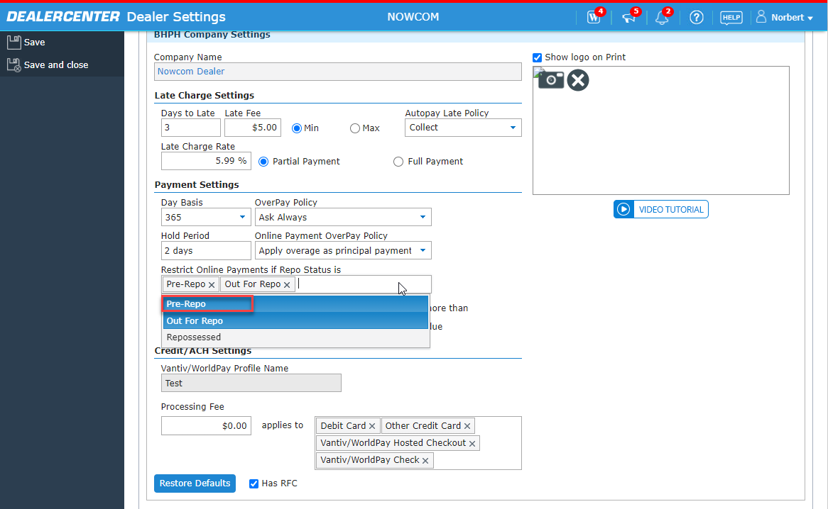

CRM

290049 - Appointment Confirmation mechanism

Customers will be able to confirm appointments that have been scheduled by Dealership. There is a hyperlink in the Appointment scheduled Email.
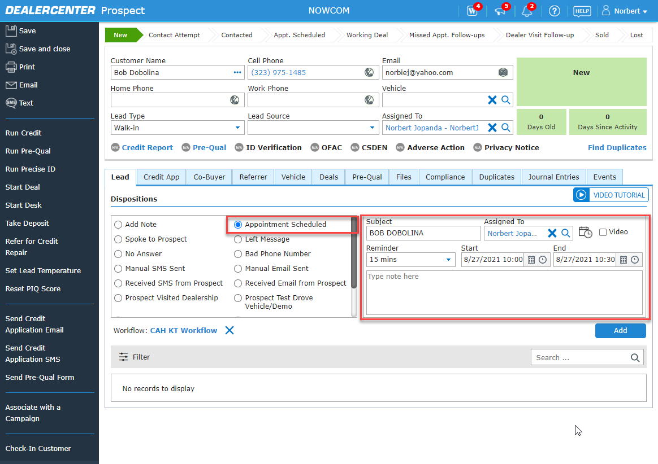

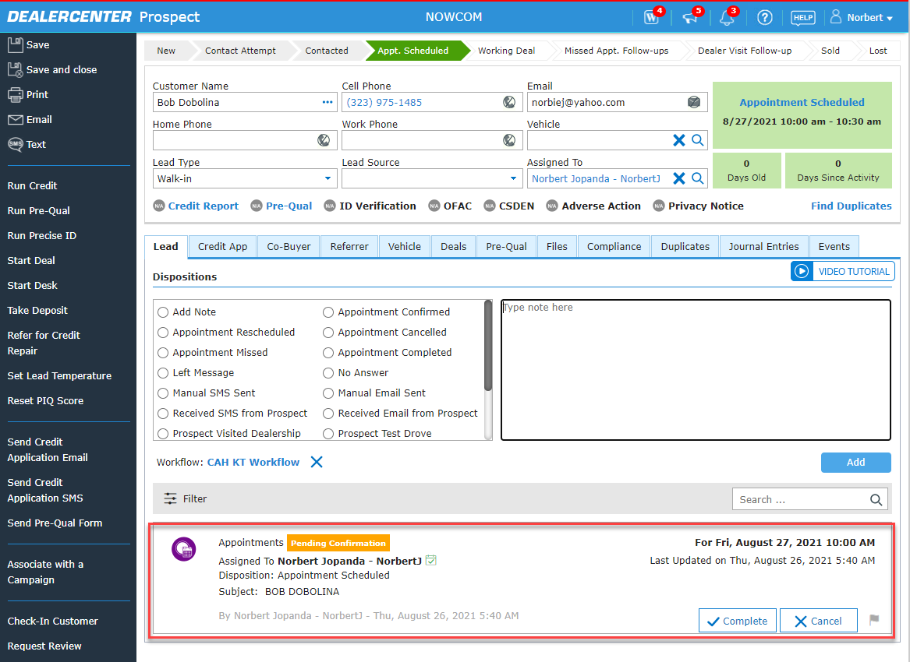

Once Customers confirm the appointment by clicking the 'Confirm' hyperlink, Dealership users will see the appointment “Confirmed”.
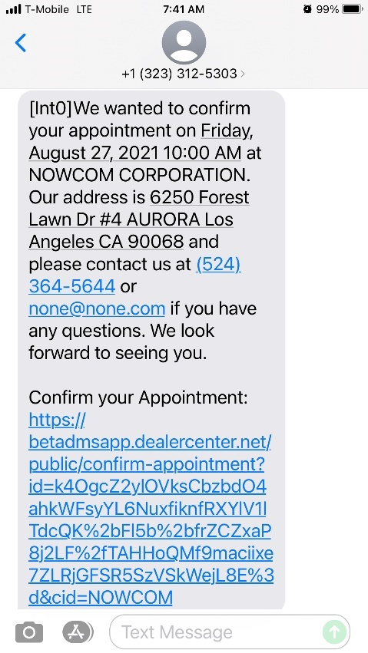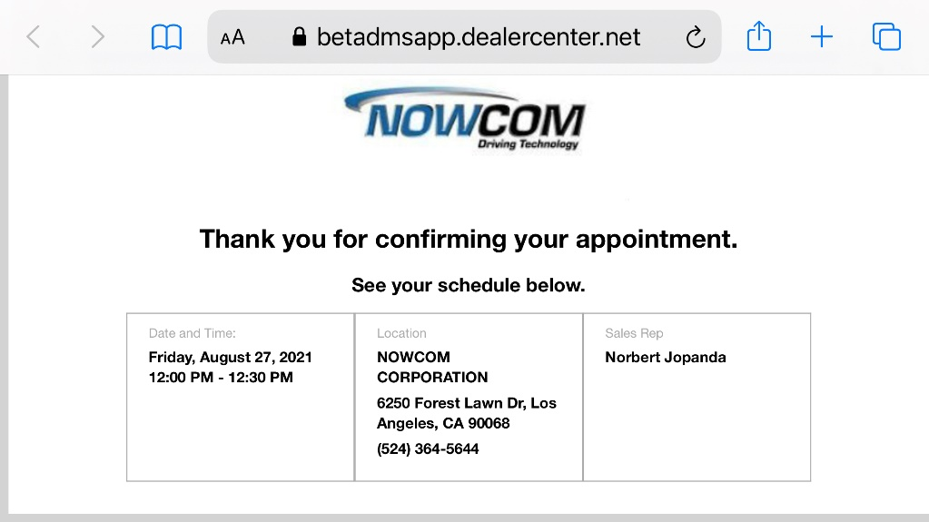
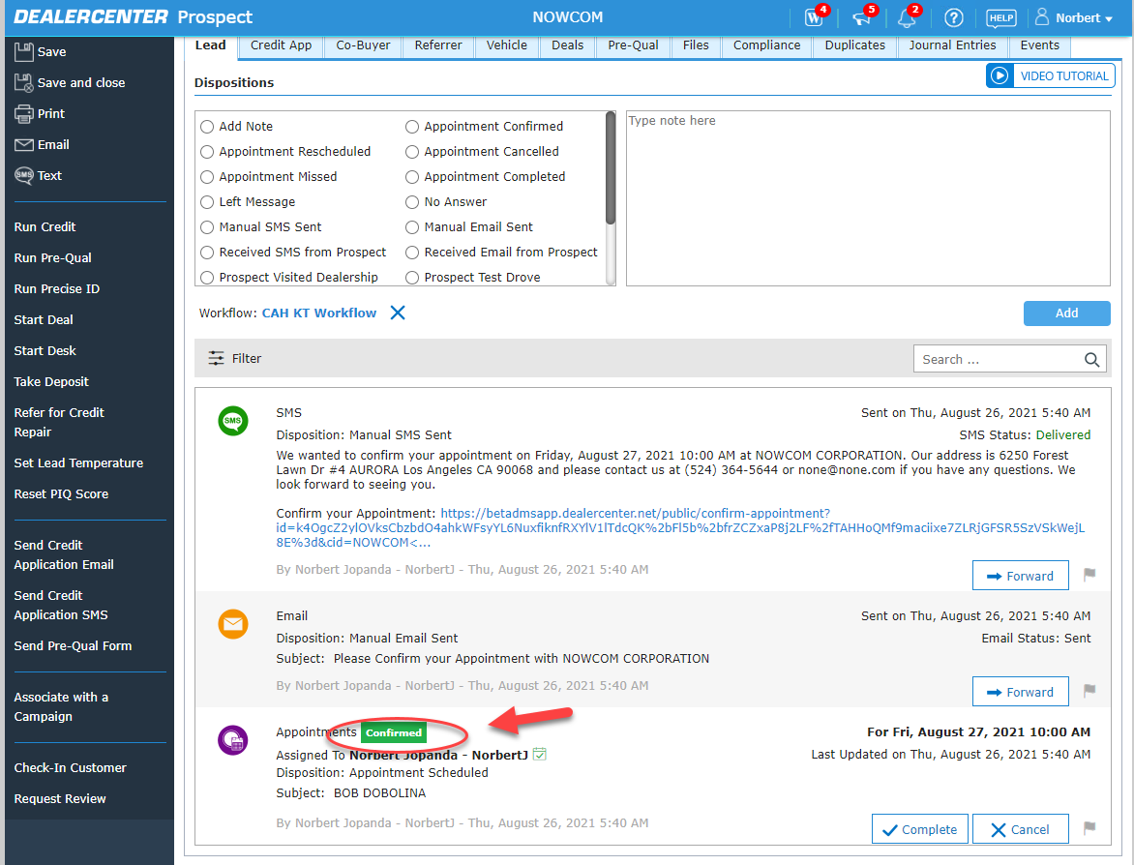

Customers who have confirmed the appointment will also receive a 'Thank You for Confirming your Appointment” message.

Email
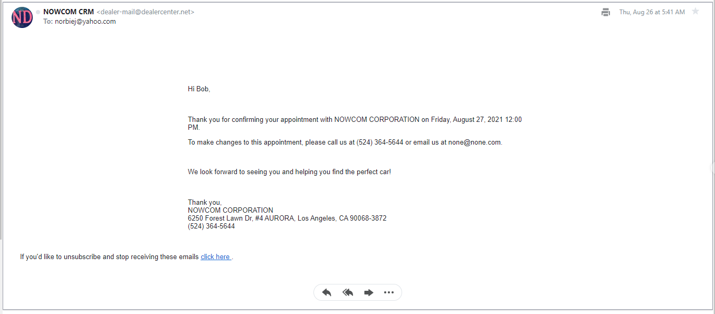
SMS
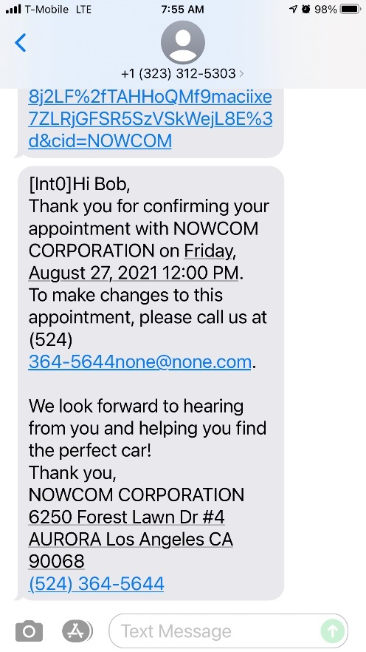

Appointment reminder emails and SMS’s will also include the 'Confirm' button if the appointment has not been already confirmed.
If Customers click on the Confirm hyperlink after the appointment has ended, a message will notify the dealer.
If Customers click on the Confirm hyperlink for second time after already confirming, they see the same Thank You message just like when they clicked and confirmed the first time.
If Customers click on the Confirm hyperlink after the appointment has been cancelled, a message will let the customer know that the appointment has been cancelled.
If Customers click on the Confirm hyperlink after the appointment end time has passed (completed), a message will notify the customer that the meeting has passed.
If Customers click on the Confirm hyperlink after the appointment has been rescheduled, a message will let the dealer know it has been rescheduled.
Dealership users are able to Confirm appointments requested by Customers via the 'Appointment Request'.
  - This is available to dealers only for the automatic appointments created upon customer request, from Dealer Website Appointment Request form.
  - Manually created appointments by users at the Dealership will not have this Dealer Confirmation function.
If a Dealers cancels or reschedules an appointment, an email to the customer indicating of this update will be sent. The new Confirm and Join buttons will be linked to the newer appointments in the rescheduled email, and the Confirm and Join buttons in the previous appointment related emails will not be valid.
Dealers will be able to disable the confirmation mechanism using a setting in the Voice, Email, and SMS options tab. Default is turned OFF.
All existing logic around Appointments will stay the same regardless of whether Customers or Dealership users Confirm appointments or not.
A 'Confirmed' column (after Made column) in the 'Appointments Report' and 'APPOINTMENTS' will added in the Dashboard.

DEAL

363293 - Deal/Lender Partner - New Reserve Settings

We have added an additional setting to allow dealers to set the reserve amount on a finance deal to be based on a percentage of the amount financed. This is a common reserve calculation in the industry.
The reserve settings can now be set by three options:

- Flat Reserve – a flat dollar amount the finance company will pay the dealer
- Percentage of the amount financed
- Participation rate – Percentage of the additional interest gained by marking up the rate from the buy rate to the contract rate.

Currently – Vendor profile
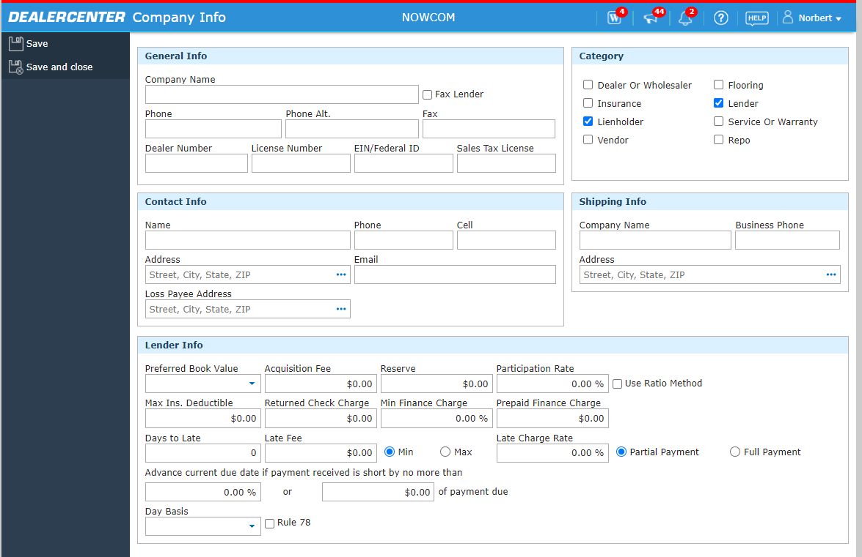

After Deployment - Vendor profile

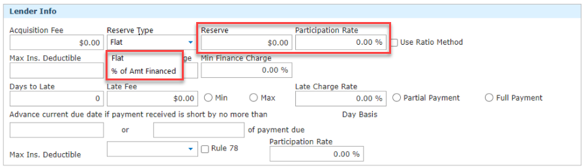

395397 - Review the list of Required fields for running Credit Report button click on Deal Entry/Desking form.

REQUIRED FIELDS

Quick Credit:
- Last Name
- First Name
- SSN
- Date Of Birth
- Address (Street, City, State, and Zip)

Deal Entry Form: Cash Deals (Run/View Credit):
- Last Name
- First Name
- SSN
New Required Fields
-- Date of Birth
-- Address (Street, City, State, and Zip)

Deal Entry Form: BHPH Deals (Run/View Credit):
- Last Name
- First Name
- SSN
- Date of Birth
New Required Fields
-- Address (Street, City, State, and Zip)

Deal Entry Form: Finance Deal (Run/View Credit)
- First Name
- Last Name
- SSN
- Date of Birth
- Rent/Mortgage
- Length At Address
- Income Type 1
- Income 1 (Monthly)
- Length at Job
New Required Fields
-- Address (Street, City, State, and Zip)

Deal Entry Form: Finance Deal (Find Vehicle Using I-Maxx)
- First Name
- Last Name
- Date of Birth
- Rent/Mortgage
- Length At Address
- Income Type 1
- Income 1 (Monthly)
- Length at Job
New Required Fields
-- SSN
-- Address (Street, City, State, and Zip)

393813- Nicholas Financial Enable Auto submit Nationwide

For Nicholas Financial, the Auto submit function will be enabled.

If a Nicholas Financial deal is aligned, then the deal will Auto Submit to Nicholas Financial.
If a Nicholas Financial deal is not aligned, dealer will have to manually submit.
If the deal is a hard stop, the dealer will not be able to submit ( Currently Nicholas Financial does not have a hard stop )

**Hard Stop is when a deal is completely outside of the banks lending guidelines. These are set by the bank.
Some examples: Cars older than 2005, Mileage over 120K regardless of year.

This will pilot in OH and then extend to other states.

350418 – Nicholas Financial – Expansion to Arizona (Deployed 7/20/2021)

Nicholas Financial expansion to Arizona was deployed back on 7/20/2021. Nicholas didn’t activate any dealers until the night of 8/26/ 2021. Qualifying dealers in Arizona will now see Nicholas financial.

402904-Add other fee description to CA

Dealers in California will be able to add “Other Fee Description”. The “Other Fee Description” will reflect on the appropriate forms.
Below forms should be updated with “Other Fee Description”
- Law 553 form
- Buyers Order
- RIC Late Fee ARB

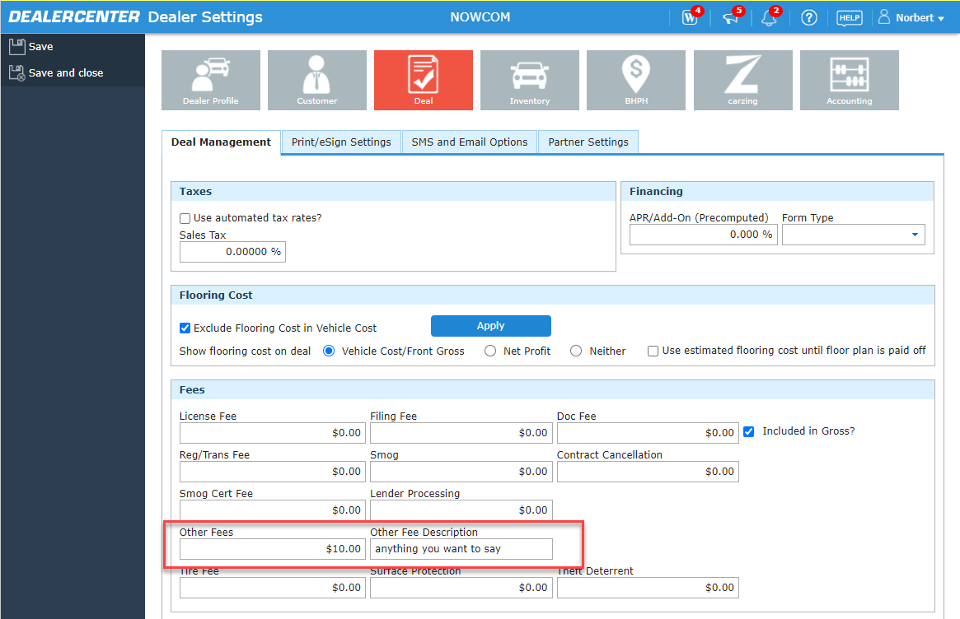
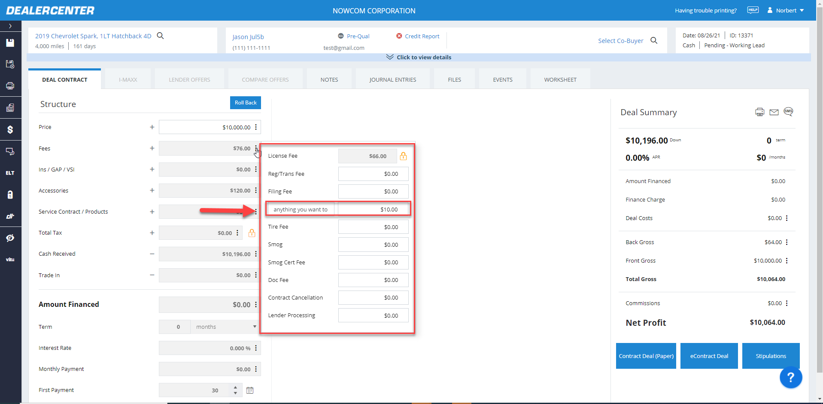

Page 2 of LAW 553
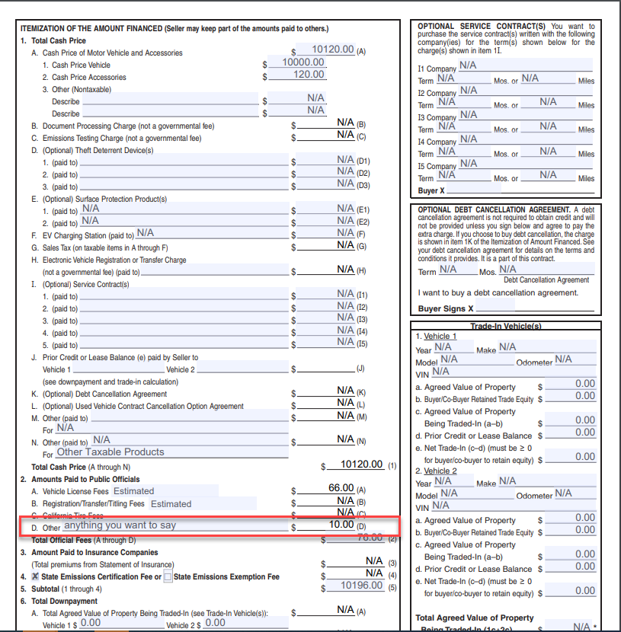

Buyers Order X
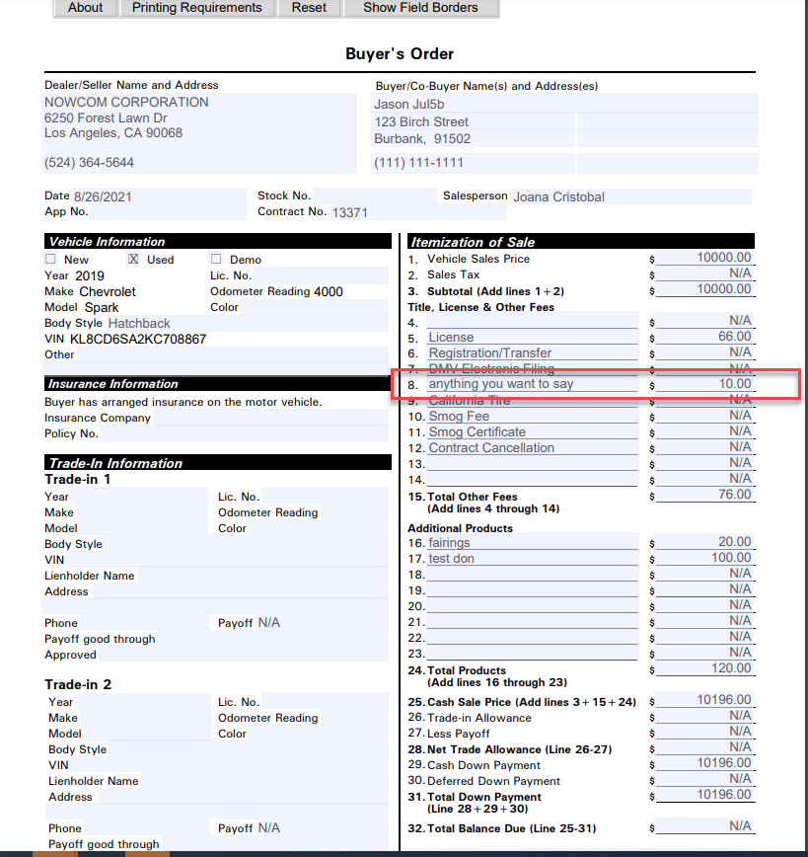

RIC Late Fee ARB

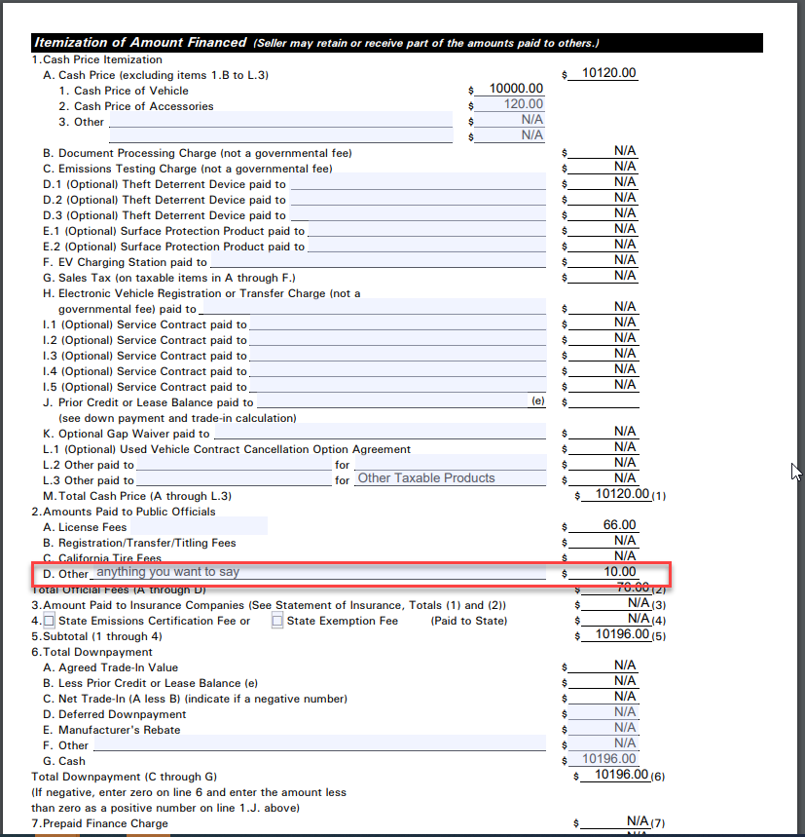

405262 - OneMain State Expansion - Sept East

One Main is expanding to additional states.
Delaware
Florida
Georgia

Indiana
Maryland
Maine
Michigan
North Carolina
New Hampshire
New York
Ohio
Pennsylvania
South Carolina

Inventory

378095: Booking changes (BB/KBB/NADA)

- Add New Vehicle
  - Added breakdown of Black Book Historical Adjusted Values
  - Odometer Adjustments and History Adjustments
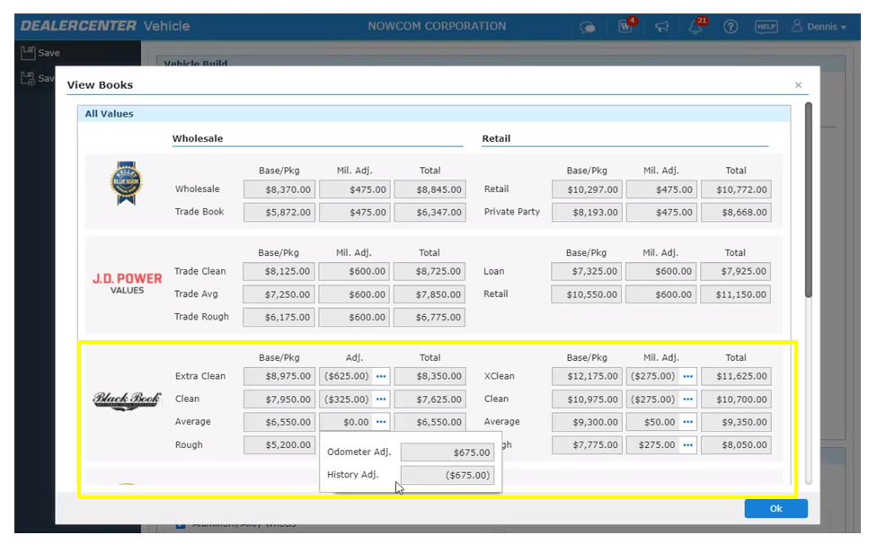

- Kelly Blue Book – VDP Changes
  - Added Fair Purchase Price & Market Range
    - Fair Purchase Price reflects the price consumers are typically paying for this vehicle
    - Fair Market Range is an estimate of what you can resonably expect to pay this week for a vehicle with typical mileage

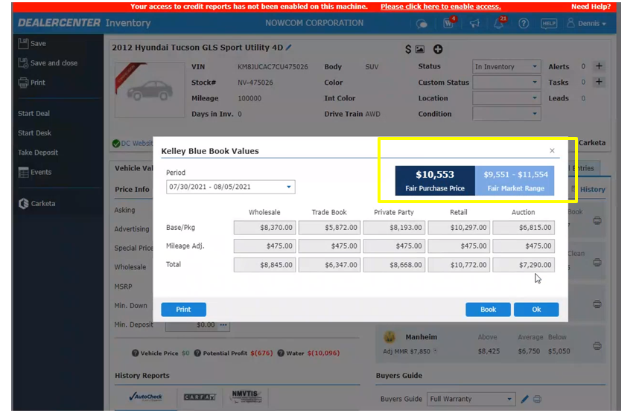

- J.D. Power Values – VDP Changes
  - Added Auction section
    - Estimated values of what vehicles may be sold for at Auctions
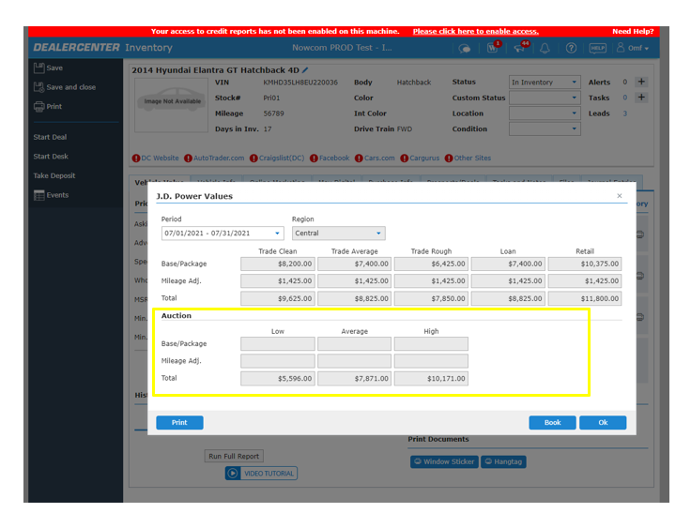
- Black Book Values – VDP Changes
  - Added wholesale, retail, trade & finance breakdown
  - Added Historical Adjusted Values
    - Historical Adjusted Values are VIN specific analytics-driven resource that delivers Black Book’s most precise vehicle valuations, helping dealers determine the impact a vehicles history has on its value
    - Adjusted values
  - When clicking on “Book”, we pull the latest values (we no longer support previous periods)

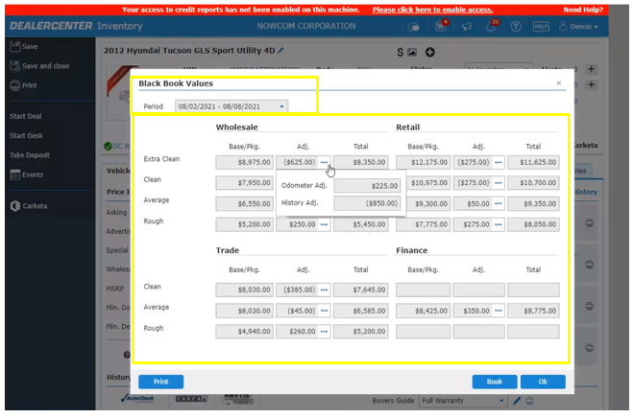

- Print icon
  - Added printing flexibility for the dealer to select value needed ( Condition specific )
  - Currently we only give dealers the ability to print all conditions
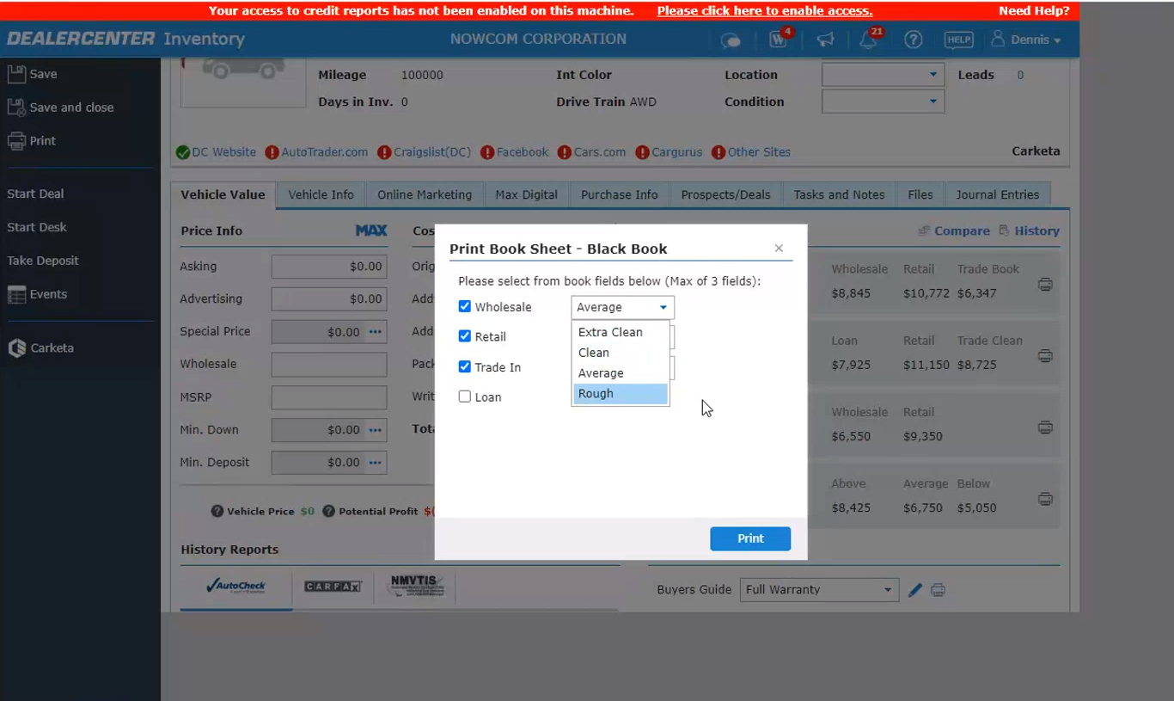

- FastBook/Appraisal
  - Same changes applied for FastBook/Appraisal
Kelly Blue Book
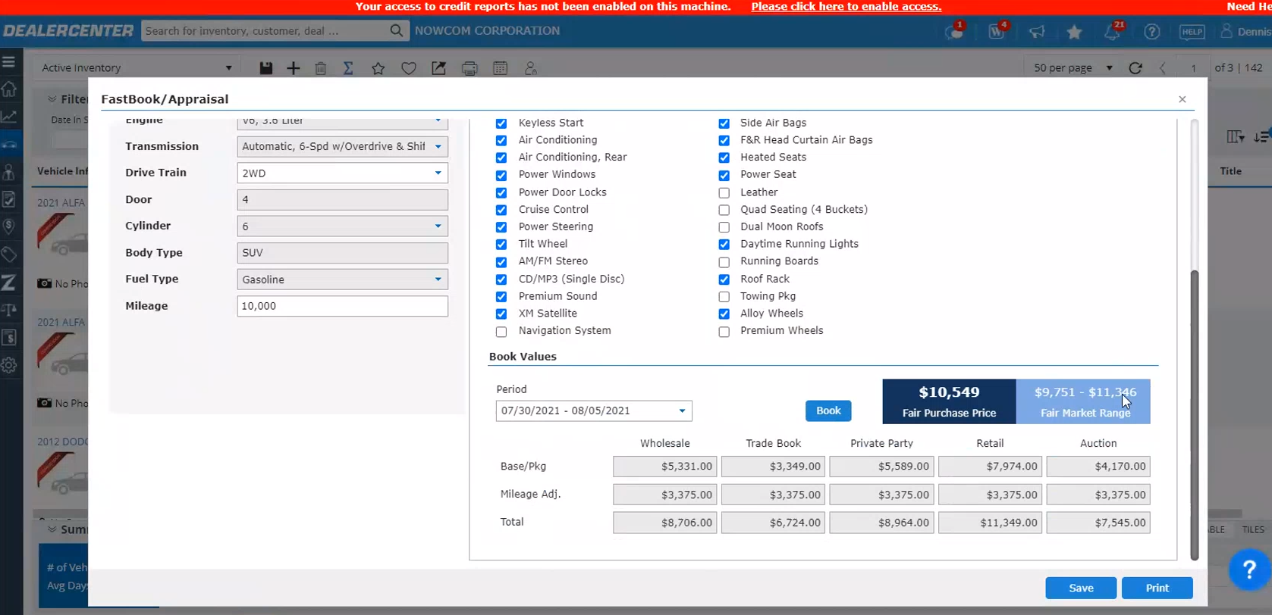

JD Power
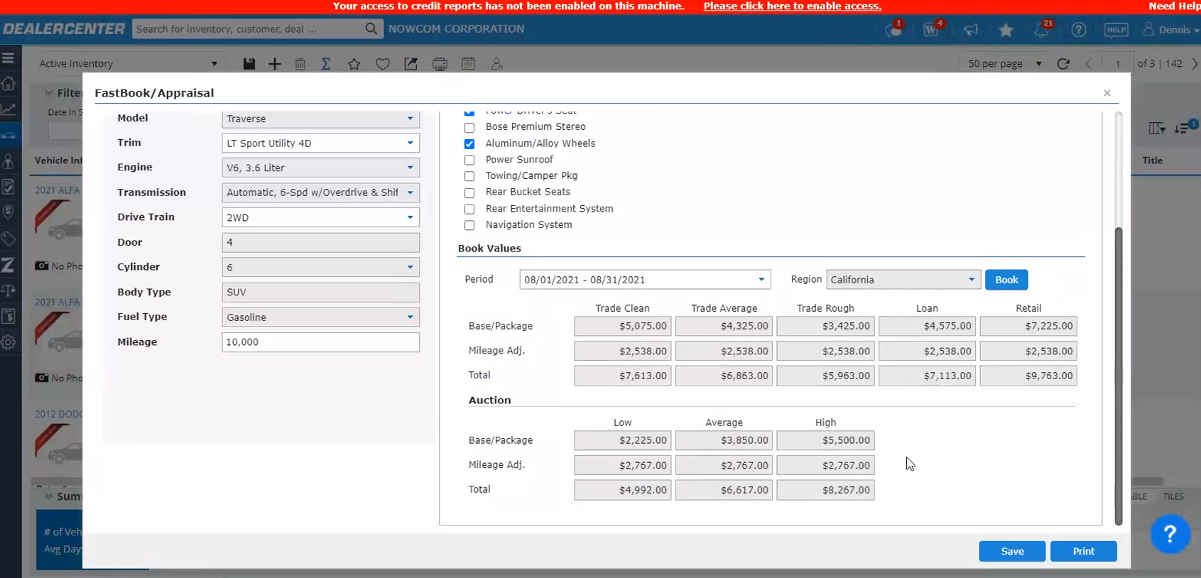
Black Book
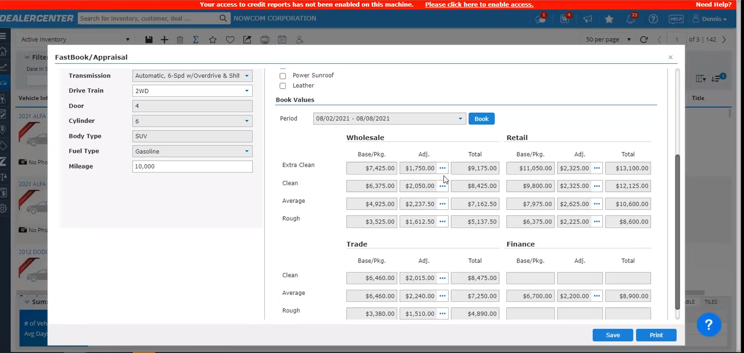
After the vehicle is saved, we get WFS Values
  - It will use dealers account for booking KBB/NADA/BB WFS Values

- Dealers without a Subsciption to NADA
  - Will get the WFS Values, using WFS account for NADA
  - No longer booking for Black Book
  - If dealer has KBB OR NADA we will use those values
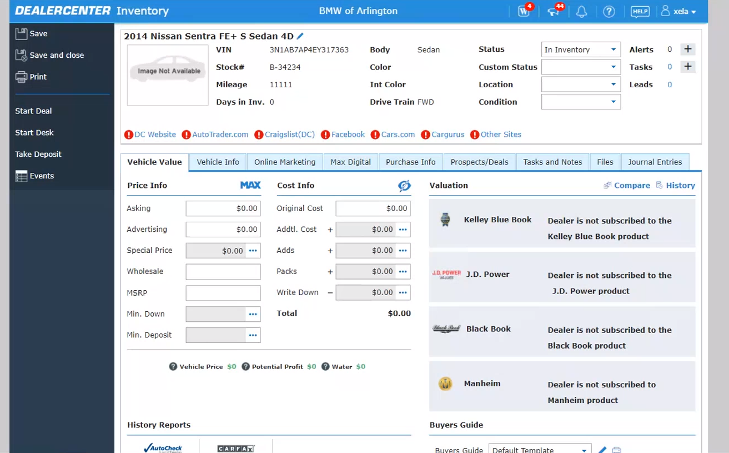
- Please note: If the vehicle is a Commercial Vehicle
  - Dealers get NADA Valuation without having a subscription

- History Link
  - Removed Black Book Historical Values
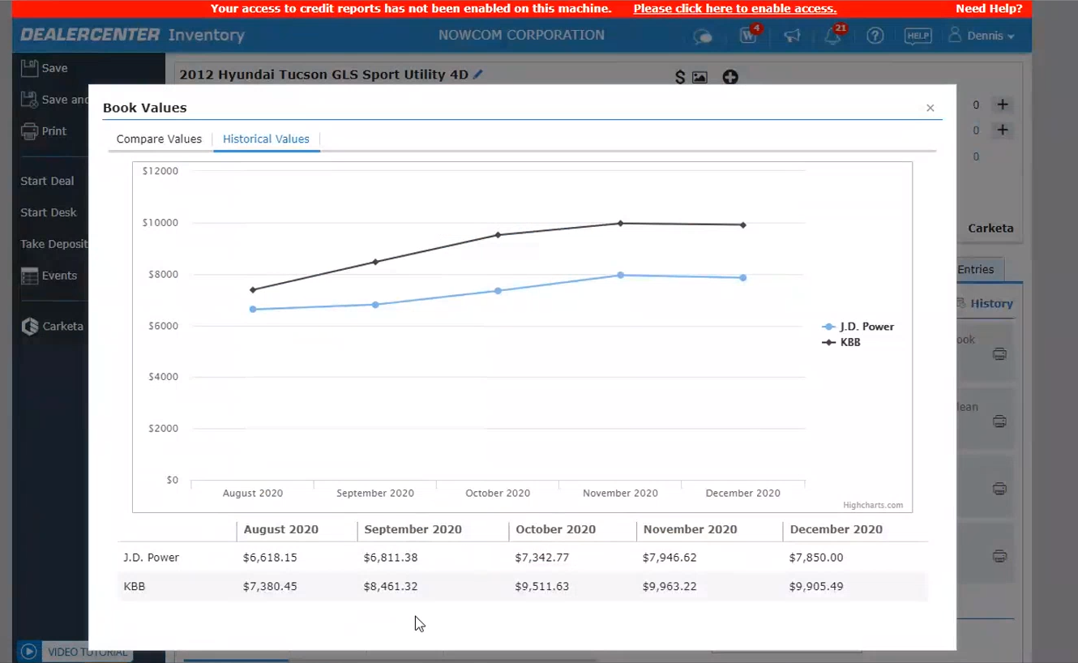
- Inventory Reports
  - View Designer Report – we have added the all-new Black book Historical total values on Columns for display.
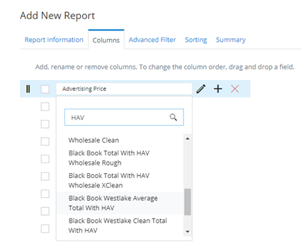
- Inventory Custom reports should now display the Black book values based on the new total with Historical in all the applicable reports with Valuations. We also have updated the Print and Export with this change.
  - Active Inventory
  - Active Inventory Detailed
  - All Inventory
  - Appraisal Summary
  - Appraisals
  - Loan to Book Calculator
  - Price List
  - Price Summary - Max Digital
  - Vehicle Values
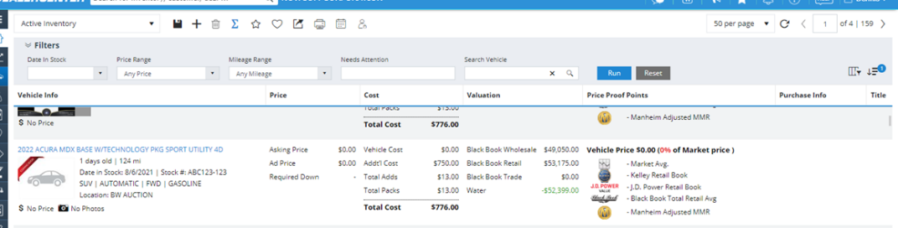
- Auction Detail Page
  - Valuations section - on Kelly Blue Book Auction values has been added on the display, on Black Book we have added the Trade and Finance.
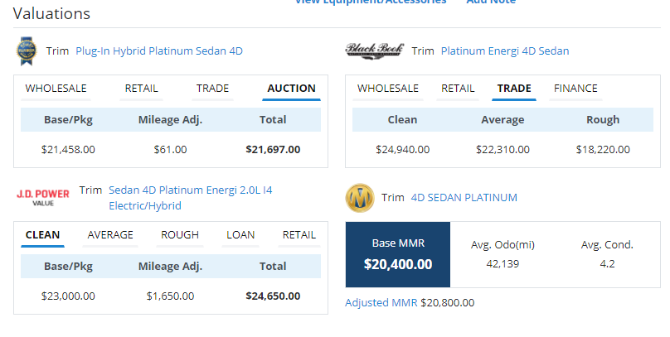
  - Kelly Blue Book dialog - Fair Purchase Price, Fair Market Range and Auction values has been added on the display
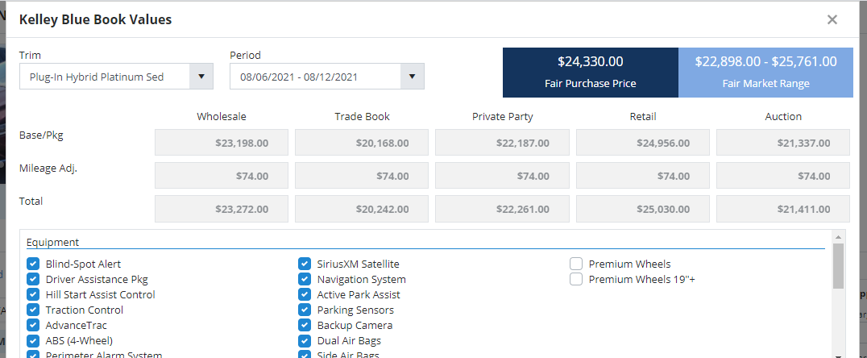
  - JD Power Book Values dialog - Auction values has been added on the display
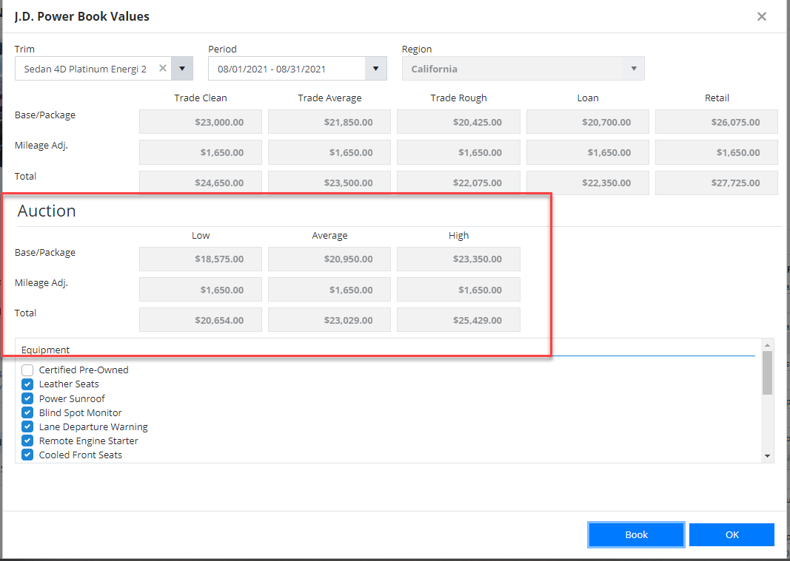
  - Black Book dialog - Period selector has been disabled and Historical values are now displayed.

  - Auction Email - for Black Book we now show the Historical Adjusted Values
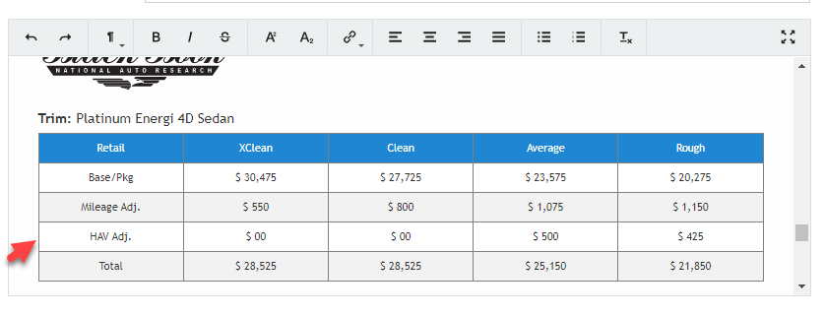

- Book Sheet Change
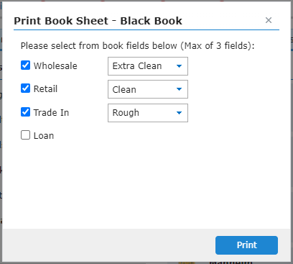
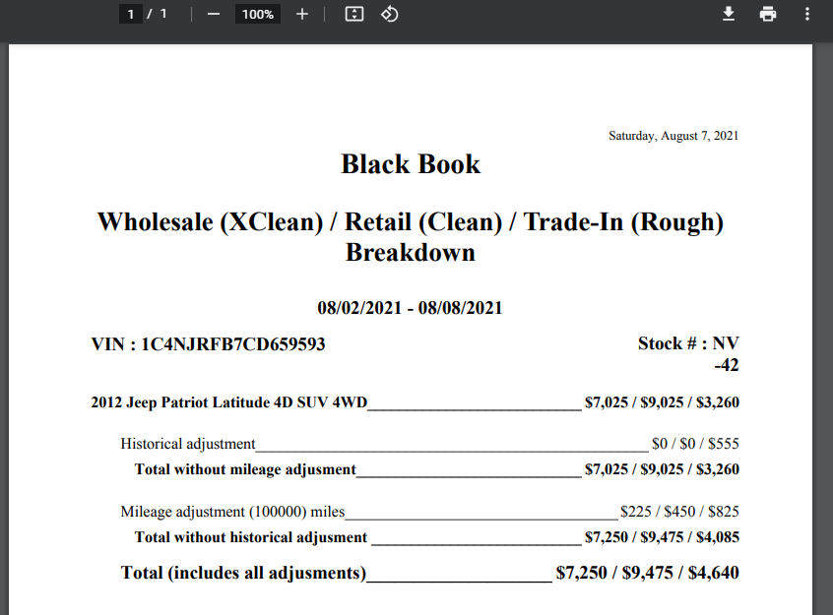

- Black Book Summary Changes:
  - We will continue building Black Book, but now we have removed the automatic booking of Black Book values for WFS. Black book will only book using the dealers book subscriptions. If dealer has no subscriptions, we now automatically book Kelly Blue Book for Westlake values if the dealer is a Kelly State and we automatically book J.D. Power if the dealer is a NADA State. This would impact the CSV Import, Inventory Importer, and Inventory Mobile.
  - On any trigger for rebook, we should rebook the Westlake values for a given Book type, if that is the book used for getting Westlake values on inventory. Otherwise, we will clear the Westlake specific fields. For example, for Kelly Blue Book State dealer without (KBB and BB subscriptions), on mileage change, we should rebook KBB and if there is a BB value (created from Deal) we should set the Westlake related columns to null, so that deal, on deal load can rebook BB with latest mileage.

325004 - Max Digital Improvements – DealerSettings

For MAX Digital, we’ve added an additional setting to have the option to adjust for -/+ years from the vehicle year of the dealer’s vehicle. Once applied, the vehicle record will show the listings of the vehicles within the year range that the dealer has applied in their settings.

Current:
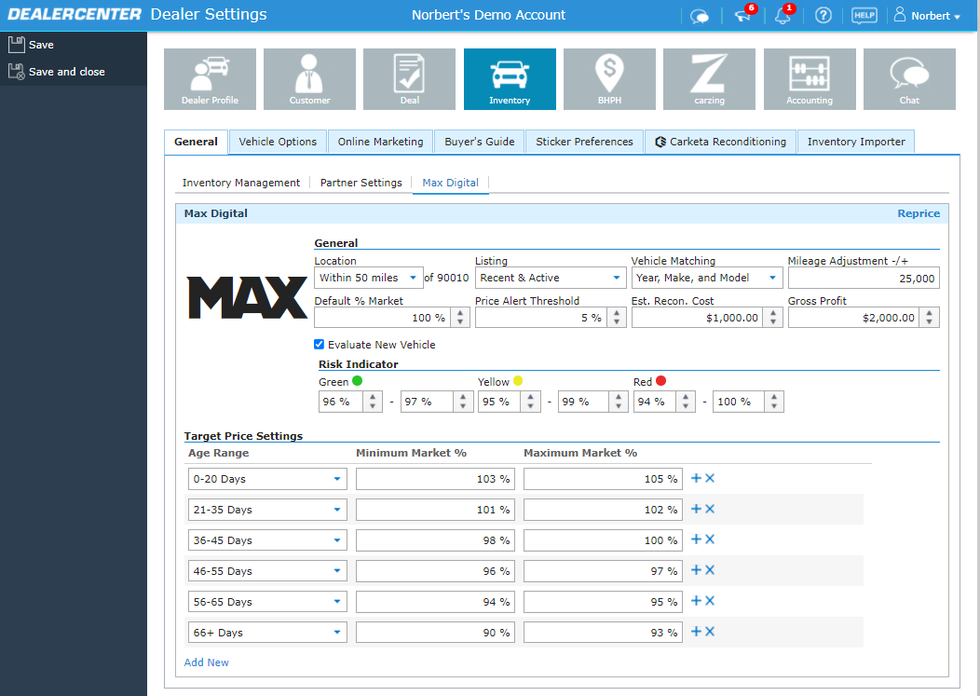
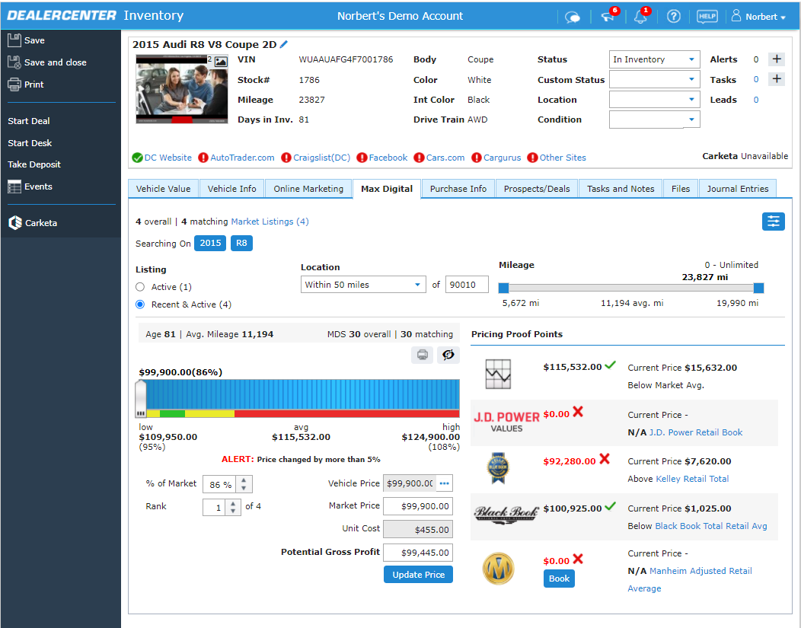
After the Deployment:
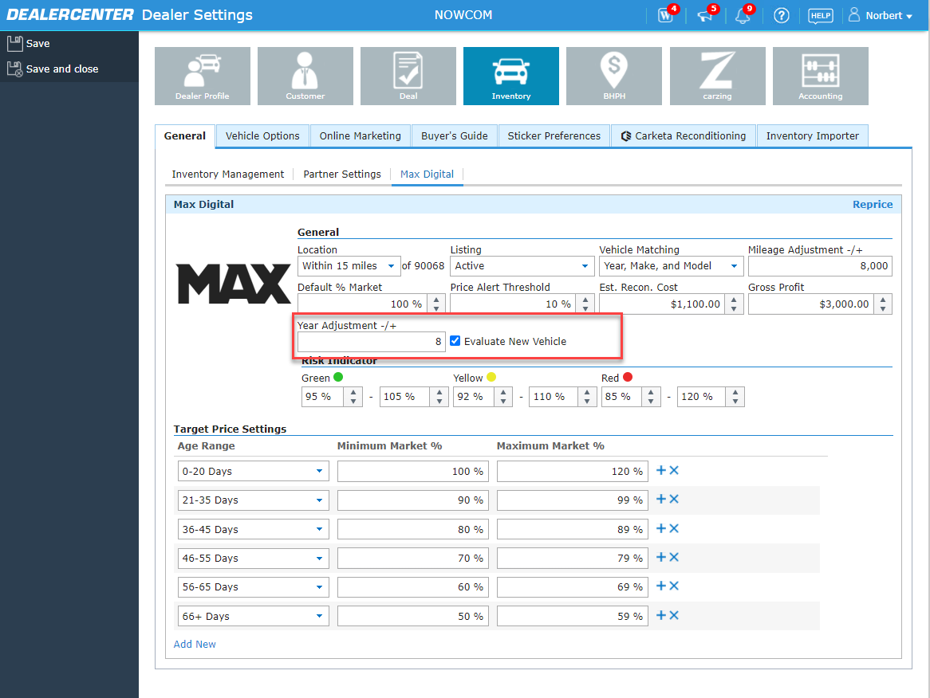
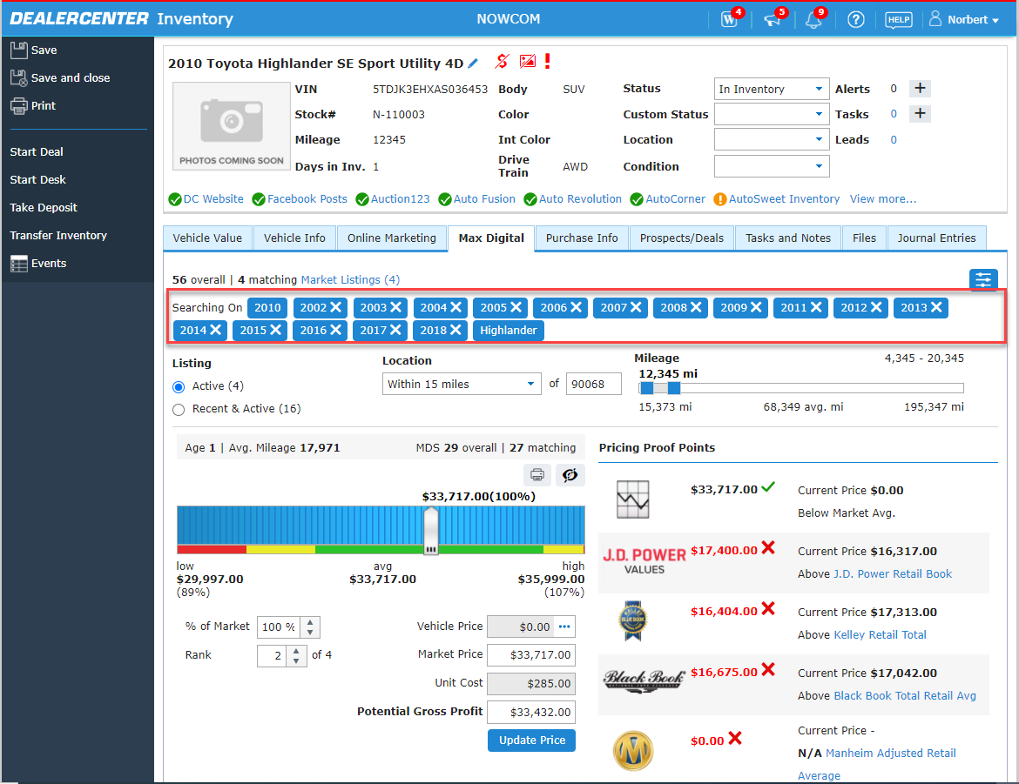

331365 - Max Digital Improvements - Price Summary

In MAX digital, we are allowing dealers to change the settings when they are repricing their inventory.
- When a dealer Click’s on Reprice Button, a new Popup will show to confirm if the dealership would like to reprice after making filter changes.
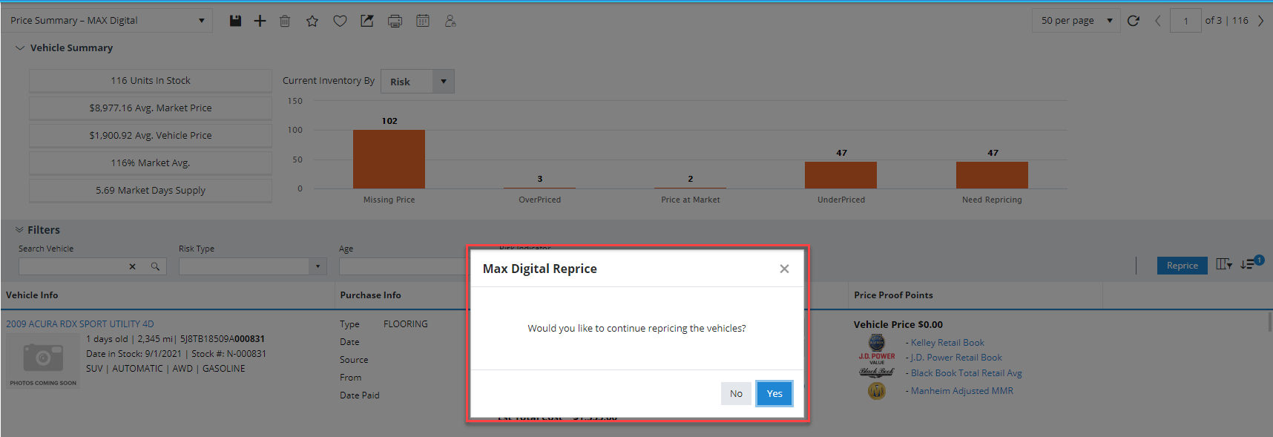

- The list of option selection from Dealer Settings: Location, Listing Type, mileage, year
- Show list of vehicles at the bottom. Update this list once that vehicle is reprice.
- At the end of reprice, show summary of how many repriced vs not reprice.
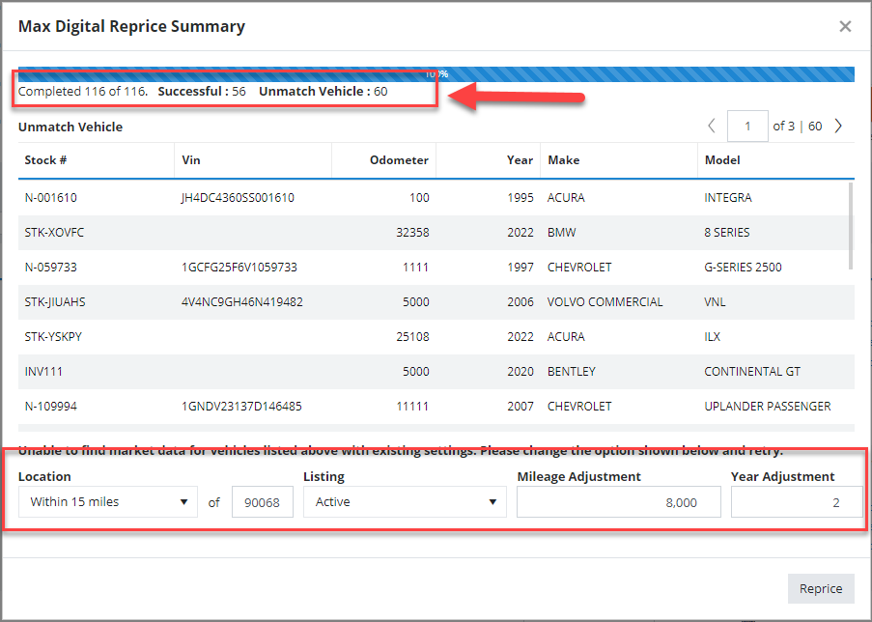
- User should be able to filter the not repriced ones, and change the filters and reprice again
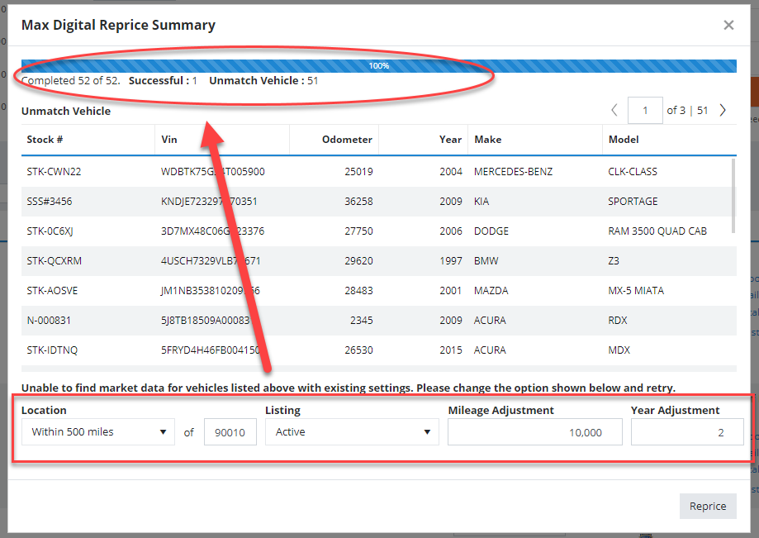

DealerCenter Mobile

377738 - Booking Changes (BB/KBB/NADA)

We applied the same changes as on the Desktop App were applied to the Mobile App inventory screens
Kelly Blue Book NADA/JD Power
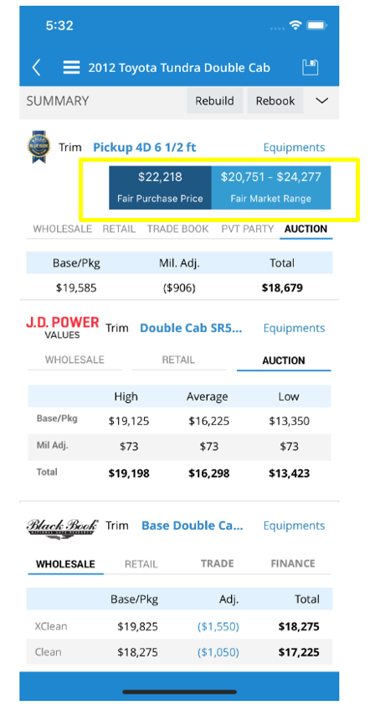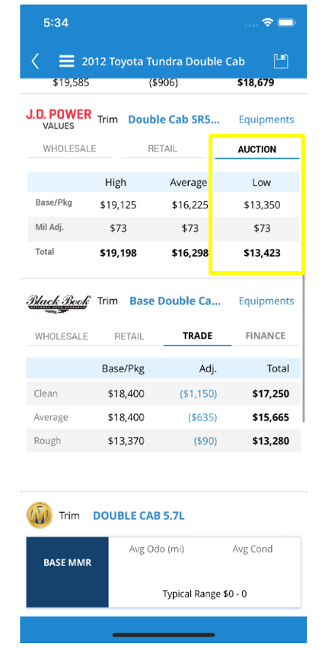

Black Book
- Added Odometer Adjustments
- Added History Adjustments
